Charlotte Cabrera

Northwestern Bootcamp 2019

Date: 06/18/2019

Where we are seeing the largest use of services in in the Urban area at 68.4%. Followed by Suburban which is at 26.3% and a small about of usage in Rural at 5.3%.

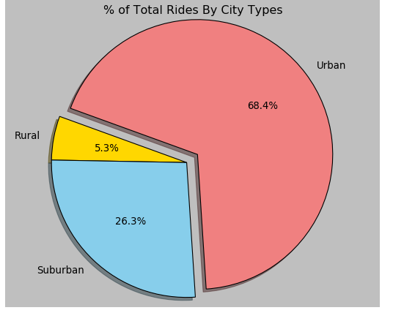

Correlating charts in which Fare Revenue is seen the largest in the Urban area at 62.7%. Suburban at 30.5% and Rural at 6.8%.

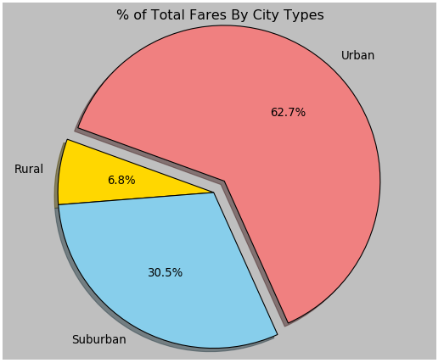

Lastly, the below pie chart confirms that where there’s demand there too is an increase of driver opportunity / employement. Urban percentage of driver – topping the charts at 80.9%.

